Multi-Line Insurance Policy and Claims Management System

User Story:
Multi-Line Insurance Policy and Claims Management System is designed to provide a centralized Salesforce-based solution for managing Vehicle, Property, and Life Insurance policies and claims. The system enables insurance agents to create and manage policy information using a flexible data model with policy-specific Record Types and Field Sets. Guided Screen Flows simplify policy quoting, while Apex automation calculates premiums based on policy and vehicle details. Claims are automatically routed to the appropriate queue based on policy type, and high-value claims are processed through an approval workflow involving Senior Adjusters and Claims Managers. An LWC-based Claims Dashboard provides adjusters with a focused view of their assigned claims, including claim amount, policy type, policy holder, status, and days open. This initiative improves policy processing efficiency, claim handling, data accuracy, operational visibility, and customer service.

INTRODUCTION

Project Overview :

The Multi-Line Insurance Policy and Claims Management System is a Salesforce-based solution designed to centralize and streamline the management of Vehicle, Property, and Life Insurance policies and claims. The system replaces fragmented and manual processes with structured Salesforce objects, Record Types, Field Sets, Flows, Apex automation, Approval Processes, and Lightning Web Components.
The solution enables insurance agents to create and manage policies through a flexible data model, while guided Screen Flows simplify the policy quoting process. The system validates policy information and uses Apex automation to calculate premiums based on factors such as state and model year. Once a claim is created, automation identifies the related policy type and routes the claim to the appropriate claims queue.

For claims adjusters, an LWC-based Claims Dashboard provides visibility into assigned claims, including claim number, policy type, policy holder, claim amount, approval status, and days open. High-value claims exceeding the defined threshold are processed through a structured approval workflow involving Senior Adjusters and Claims Managers. Security and access are managed using sharing rules and role-specific Permission Sets.

Overall, the project provides a centralized platform for improving policy processing, premium calculation, claim routing, claim approval, data accuracy, operational visibility, and customer service across multiple insurance lines.

Purpose :

The purpose of the Multi-Line Insurance Policy and Claims Management System is to provide a centralized Salesforce-based platform for managing Vehicle, Property, and Life Insurance policies and claims. The system is designed to overcome the limitations of legacy processes that result in manual, slow, and inconsistent quoting, policy issuance, and claims handling.

The solution aims to standardize and accelerate policy quoting and issuance, automate claim initiation and routing based on policy type and claim severity, and provide a 360-degree view of Customer, Policy, and Claim information. It also supports guided quoting through Screen Flows, automated premium and claim processing, data validation, and an LWC-based dashboard to improve claims adjuster efficiency.
Overall, the project focuses on improving operational efficiency, data accuracy, claims processing, and customer experience by bringing multiple insurance lines into a unified Salesforce solution.

IDEATION PHASE

Problem Statement (Customer Problem Statement Template)

PS | I am (Customer) | I’m trying to | But | Because | Which makes me feel
PS-1 | Insurance Operations Manager | standardize policy quoting and issuance | the process is manual, slow, and inconsistent | legacy systems and processes are fragmented | frustrated and concerned
PS-2 | Insurance Agent | create and manage policies efficiently | different insurance lines require different information | Vehicle, Property, and Life policies have diverse data requirement s | overwhelme d
PS-3 | Insurance Agent | provide accurate policy quotes | quoting requires multiple steps and manual processing | there is no unified quoting platform | frustrated and uncertain
PS-4 | Claims Manager | manage claims efficiently | claim review and routing are largely manual | claims processes are not centralized or automated | stressed

PS-5 | Claims Adjuster | manage assigned claims effectively | I lack a focused view of my claims workload | claim information is not easily available in one place | frustrated and less productive
PS-6 | Claims Manager | route claims to the appropriate team | claims need to be handled according to policy type and claim severity | routing processes are complex and require automation | concerned about delays
PS-7 | Senior Adjuster | process high-value claims efficiently | approval requires multiple levels of review | high-value claims require structured approval and escalation | pressured
PS-8 | Insurance Operations Manager | maintain accurate policy information | different products require different fields and validations | Vehicle, Property, and Life policies have varying data requirement s | concerned about data quality
PS-9 | Customer | get my policy and claim handled quickly | manual processing causes delays | policy and claims processes are fragmented | uncertain and dissatisfied
PS-10 | Insurance Management | get a complete view of customer, policy, and claim information | information is spread across processes and systems | there is no unified platform | concerned about operational efficiency

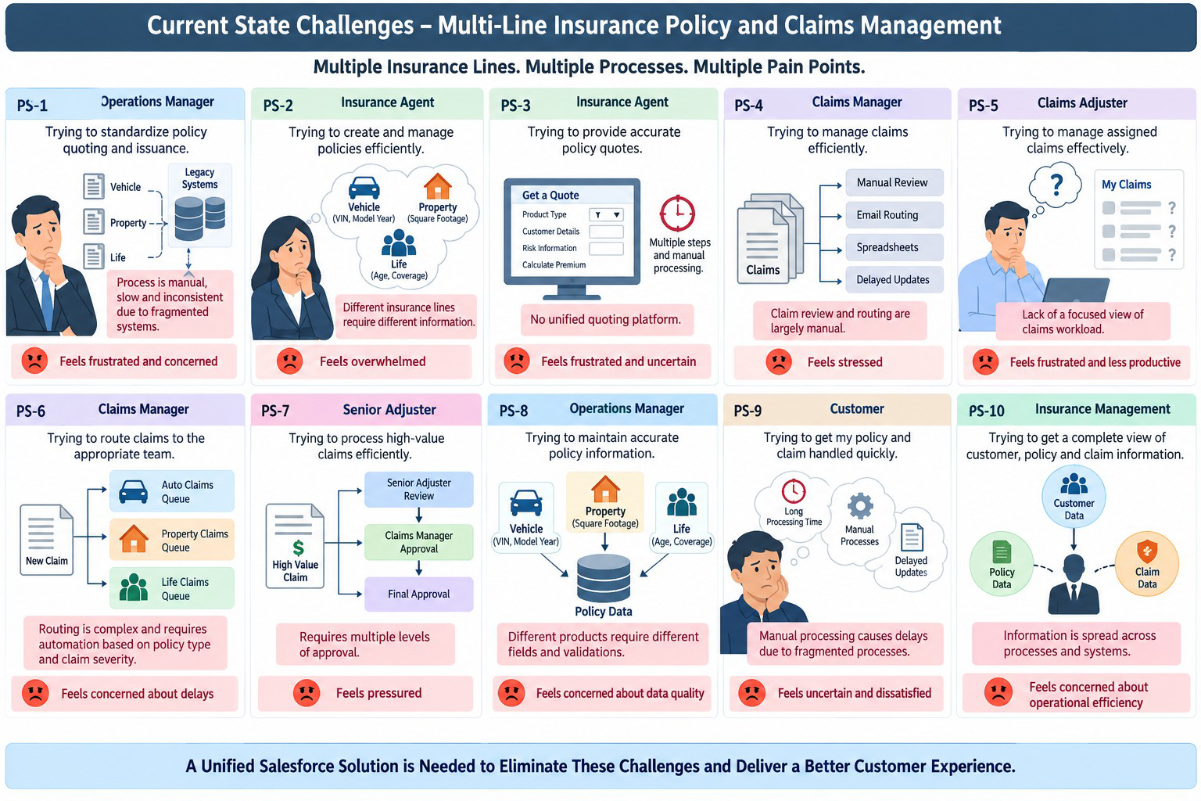

Empathy Map Canvas
User Persona: Insurance Claims Adjuster
    - Think & Feel: Concerned about claim delays and workload
    - Hear: Customer and team concerns about claim resolution
    - See: Multiple claims, policy details, and approval statuses
    - Say & Do: Reviews claims and follows up on approvals
    - Pain: Manual processing, complex routing & limited visibility
    - Gain: Claims dashboard, automation & faster approvals
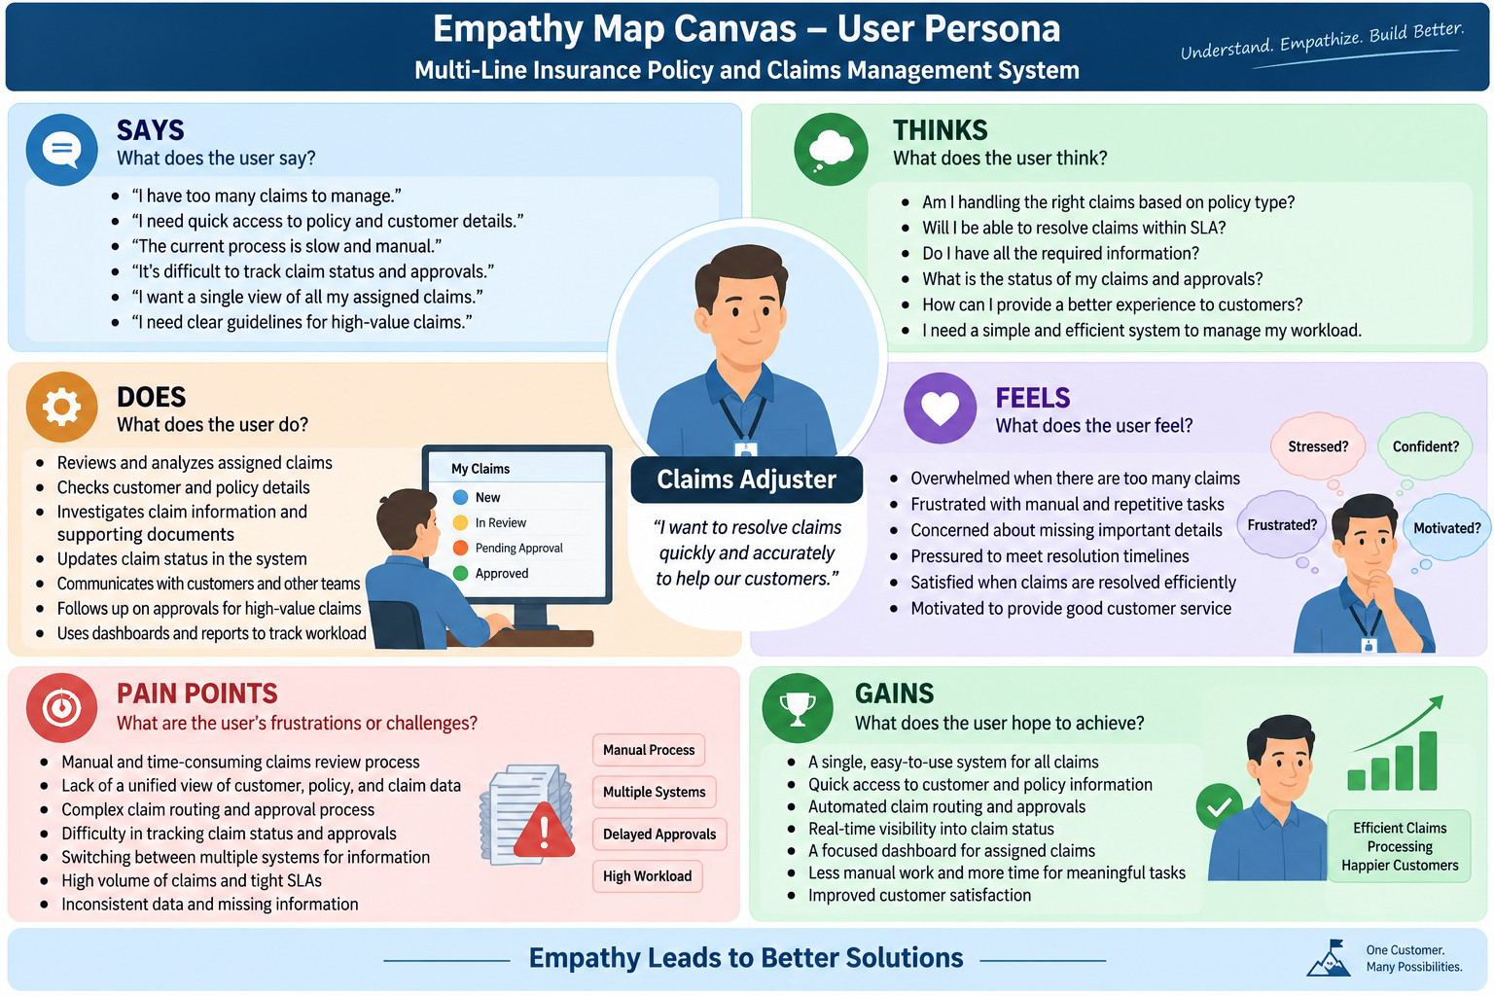

Brainstorming & Idea Prioritization

Ideas Considered
    - Manual Registers – Policy and claim information maintained manually
    - Spreadsheet Tracking – Policies, claims, and approvals tracked using spreadsheets
    - Standalone Portal – Separate portal for policy and claim management
    - Salesforce CRM – Unified platform for policies, claims, automation, and reporting

Final Selection
Salesforce CRM selected due to:
    - Automation – Automates quoting, premium calculation, claim routing, and approval processes
    - Scalability – Supports multiple insurance lines including Vehicle, Property, and Life Insurance
    - Real-Time Visibility – Provides centralized visibility into customer, policy, and claim information
    - Unified Platform – Brings policy and claims processes together in one system
    - Improved Efficiency – Reduces manual processing and supports faster claim handling

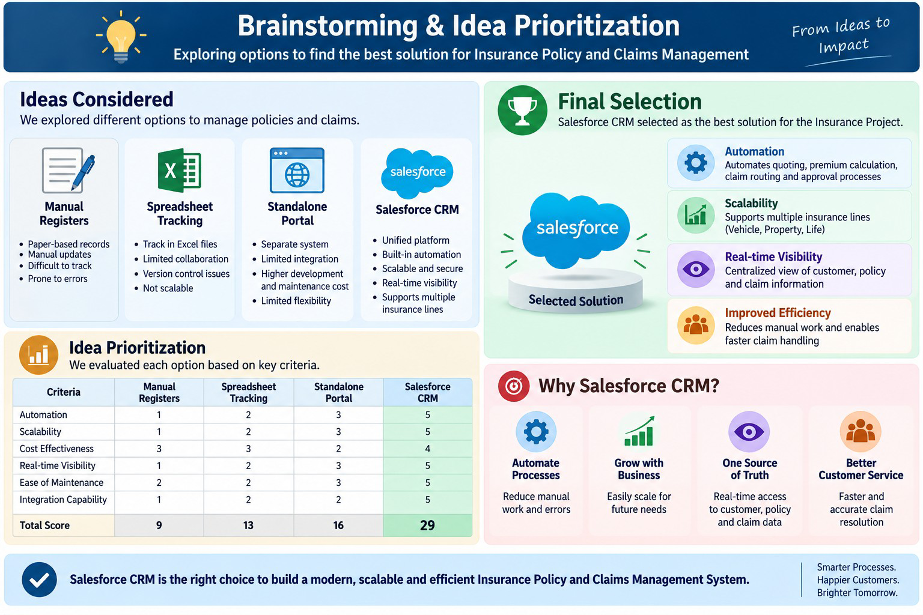

REQUIREMENT ANALYSIS PHASE

Customer Journey Map
Stages:
    - Insurance Inquiry
    - Policy Selection – Vehicle / Property / Life
    - Quote Request
    - Policy Information Capture
    - Premium Calculation
    - Policy Issuance
    - Claim Initiation
    - Claim Routing
    - Claim Review & Approval
    - Claim Resolution
    - Customer Confirmation
    - Reporting & Visibility

